Exercise 1: Inventory Management System
Scenario:
You are developing an inventory management system for a warehouse. Efficient data storage and retrieval are crucial.
Steps:
- Understand the Problem:
  - Explain why data structures and algorithms are essential in handling large inventories.

Ans: Data structures and algorithms are essential in an inventory management system because they make storing, searching, updating, and managing large amounts of inventory data efficient. Without them, the system becomes slow and difficult to scale as the number of products increases. A data structure is a way of organizing data so it can be accessed and modified efficiently.
In a warehouse, each product has information such as:
- Product ID
- Name
- Quantity
- Price
- Location
- Supplier
If this information is stored poorly, operations like searching or updating inventory can take a long time. An algorithm is a step-by-step procedure for solving a problem.
An inventory system performs many operations every day:
- Searching for a product
- Adding new stock
- Removing sold items
- Sorting products by price or quantity
- Finding products with low stock
- Generating inventory reports
Efficient algorithms make these operations much faster.

  - Discuss the types of data structures suitable for this problem.
Ans: Array/List
- Easy to store products.
- Searching for a product requires checking each item one by one.
- Time Complexity: O(n)
HashMap
- Stores products using Product ID as the key.
- Searching, inserting, and deleting are very fast.
- Average Time Complexity: O(1)

- Setup:
  - Create a new project for the inventory management system.
Ans: Done, Project created and attached
- Implementation:
  - Define a class Product with attributes like productId, productName, quantity, and price.
Ans: Done and attached
  - Choose an appropriate data structure to store the products (e.g., ArrayList, HashMap).
Ans: HashMap
  - Implement methods to add, update, and delete products from the inventory.
Ans: 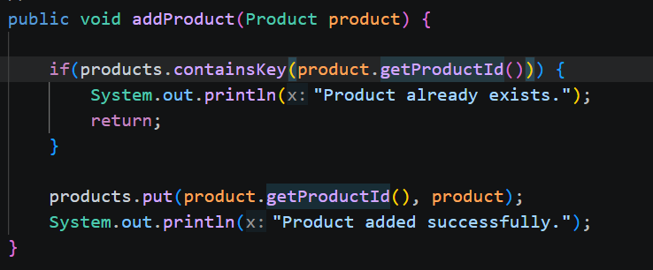

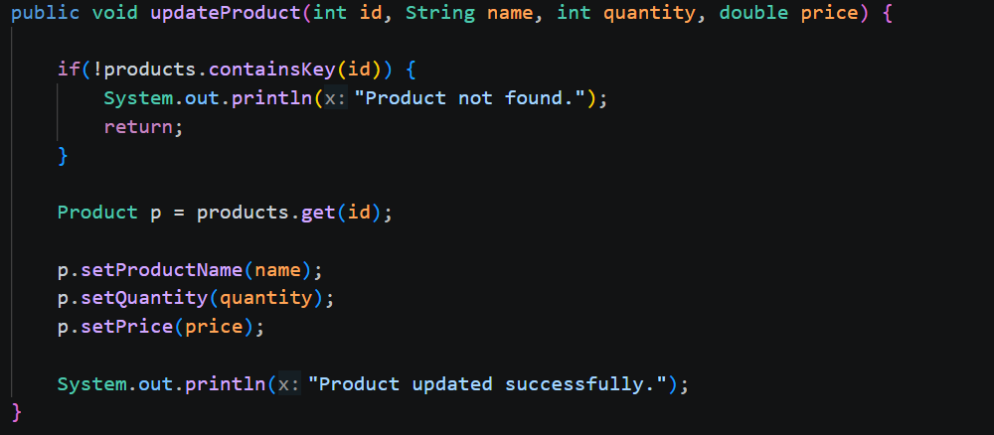

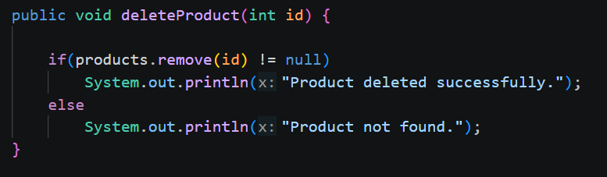

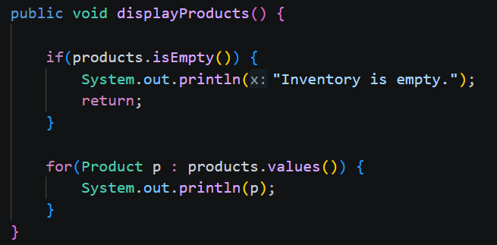
- Analysis:
  - Analyze the time complexity of each operation (add, update, delete) in your chosen data structure.
Add Product: O(1) Average, inserts the product using its productId as the key. HashMap computes the hash and stores it directly.
Update Product: O(1) Average, Finding the product by key is constant time, and updating its fields takes constant time.
Delete Product: O(1) Average, HashMap directly removes the entry using the key.
Display Product: O(n), Every product is visited once, so the time grows linearly with the number of products.
  - Discuss how you can optimize these operations.
Ans:
    - Using HashMap over ArrayList is already an optimization, since in ArrayList we would have to search every product, whereas in HashMap, the system directly accesses the product using its key.
    - If the capacity of the inventory is known, we can initialize the size of the HashMap with that capacity. This reduces computationally expensive resize operations.

Exercise 2: E-commerce Platform Search Function
Scenario:
You are working on the search functionality of an e-commerce platform. The search needs to be optimized for fast performance.
Steps:
- Understand Asymptotic Notation:
  - Explain Big O notation and how it helps in analyzing algorithms.
Ans: Big O notation is a mathematical way of describing how the running time or memory usage of an algorithm grows as the size of the input increases.
Big O notation helps developers:
- Compare different algorithms.
- Predict how algorithms perform with large datasets.
- Choose the most efficient data structures.
- Build scalable applications.

  - Describe the best, average, and worst-case scenarios for search operations.
Ans: When analyzing a search operation, we consider three cases:
- Best Case: The search completes in the minimum possible time.
The best case occurs when the desired product is found immediately.
- Average Case: The expected time for a typical search.
The average case represents the expected performance for a typical search.
- Worst Case: The maximum time the search could take.
The average case represents the expected performance for a typical search.

- Setup:
  - Create a class Product with attributes for searching, such as productId, productName, and category.
Ans: Done and Attached.
- Implementation:
  - Implement linear search and binary search algorithms.
Ans: Done and Attached.
  - Store products in an array for linear search and a sorted array for binary search.
  - Ans: Done.
- Analysis:
  - Compare the time complexity of linear and binary search algorithms.
Ans:
In Linear Search:
- Checks products one by one.
- May examine:
  - Best case: 1 comparison (first product).
  - Average case: About 500 comparisons.
  - Worst case: 1,000 comparisons (last product or not found).
Time Complexity: O(n)

In Binary Search:
The array is sorted by productId.
The search proceeds as follows:
- Check the middle product.
- Decide whether the target is in the left or right half.
- Repeat on the remaining half.
Time Complexity: O(log n)

  - Discuss which algorithm is more suitable for your platform and why.
Ans:
Binary Search is more suitable for my platform because:
1. Faster Search: Binary search reduces the search space by half after every comparison, making it much faster than linear search.
2. Scalability: As the inventory grows from hundreds to thousands or millions of products, binary search continues to perform efficiently with O(log n) time complexity.
3. Reduced Processing Time: Fewer comparisons mean quicker product retrieval, improving the responsiveness of the inventory management system.

Exercise 7: Financial Forecasting
Scenario:
You are developing a financial forecasting tool that predicts future values based on past data.
Steps:
- Understand Recursive Algorithms:
  - Explain the concept of recursion and how it can simplify certain problems.
Ans: Recursion is a programming technique in which a method calls itself to solve a problem. Instead of solving the entire problem at once, the method breaks it down into smaller, similar subproblems until a simple condition, called the base case, is reached.
A recursive function has two essential parts:
- Base Case – Stops the recursion and prevents infinite calls.
- Recursive Case – Calls the same function with a smaller or simpler input.
- Setup:
  - Create a method to calculate the future value using a recursive approach.
Ans: Done and attached.
- Implementation:
  - Implement a recursive algorithm to predict future values based on past growth rates.
Ans: Done and attached.
- Analysis:
  - Discuss the time complexity of your recursive algorithm.
Ans: Time Complexity
- Time Complexity: O(n)
  - Here, n is the number of years (or recursive steps).
  - The function makes exactly one recursive call in each invocation.
  - The years parameter decreases by 1 every time until it reaches 0.
  - Each call performs only a constant amount of work (one multiplication, one addition, and one recursive call).
The recurrence relation is:
$$T(n)=T(n-1)+O(1)$$
Solving this, gives us:
$$T(n)=O(n)$$
  - Explain how to optimize the recursive solution to avoid excessive computation.
Ans:
1. Use Iteration (Best Optimization)
- Replace recursion with a loop.
- This eliminates the overhead of recursive function calls.
- Time Complexity: O(n)
- Space Complexity: O(1)
2. Memoization (When Applicable)
- If the recursive algorithm repeatedly computes the same values (as in Fibonacci), store previously computed results in an array or HashMap.
- Future calls can reuse these stored values instead of recalculating them.
- This avoids excessive computation caused by overlapping subproblems.
3. Dynamic Programming
- If multiple forecast values are required (e.g., forecast for years 1 through n), compute them iteratively and store each result.
- This avoids repeated recursive calls and improves efficiency.

